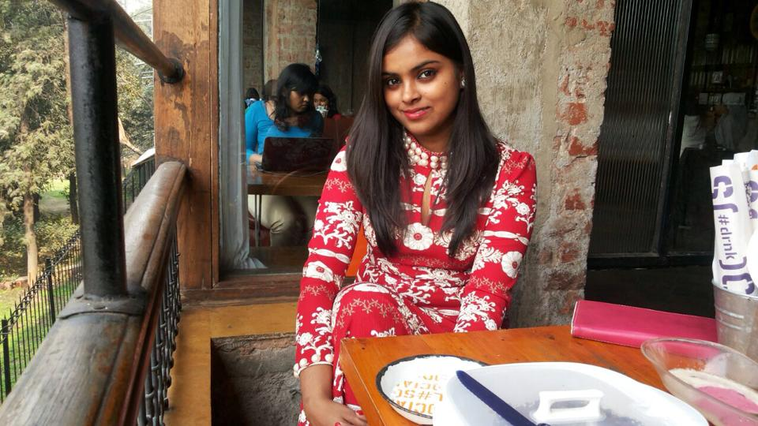
Name: A
Name: Parul Bhatnagar
Contact No: 9953332049
Email Id: parulaamir@gmail.com

Seeking a dynamic position in the domain of Management with a growth oriented organization.

OVERVIEW:

- Currently working as a Social Media Strategist at REC(Rural Electrification Corporation)under Ministry Of Power.
- Core competency and interest in the fields of Advertising/PR & Marketing
- Possess a creative instinct and an innovative approach to situations and tasks
- Possess good writing and communication skills along with good interpersonal skills

CURRENT JOB PROFILE:

Organization: Rural Electrification Corporation under Ministry Of Power

Role of Responsibility: Social Media Strategist

Tenure: 5+ months (as on 6th august 2016)

Project Titles:
1. Grameen Vidyutikaran Yojana (A massive mission to electrify 18452 villages in 1000 days run by Modi GOVT)
2. GARVAPP

Highlights of Job:
- Creating videos, photographs and other media for social media platforms in order to promote the scheme.
- Designing and strategising social media campaigns for promotion of the scheme.
- Ideation of new ways to promote the scheme on platforms other than the social media.

SUMMER INTERSHIP:

Organization: IMBIBE COMMUNICATIONS, GURGAON

Role of Responsibility: BDE (Business Development Executive)
Tenure: 2+ months
Project Title: 1. Zebra India Conference Event
2. Kings Apparel Brand Management
3. Goli Vada Pav

Highlights of internship:
- Meeting with clients
- Servicing the clients
- Preparing presentations & proposals
- Taking brief and getting the work done
- Researching on companies before pitching
- Calling the prospects
- Event planning & administration

SCHOLASTICS:

- PGDM from Institute of Marketing & Management, 1st Semester, scoring 75.69%. 2nd semester, scoring 75%.
- B.Sc (Honors) Home Science (specialization in Communication & Extension), Institute Of Home Economics, Delhi University, scoring 70%
- 12th from New Green Field School, Saket, CBSE, scoring 63%(PCM)
- 10th from New Green Field School, Saket, CBSE, scoring 79.60%

WORK EXPERIENCE:

Worked as a Content Writer in an E-commerce Website, www.Healthgenie.in for a tenure of 3 mnths.
Worked with Dramabaaz Company as one of the puppeteer of the team of 14 artists.
Worked with Imbibe Communications, as a BDE intern for 2+ months.

SKILLS:

Video/Film Making
Scripting and Story Writing
Content writing, Copy Writing
Playing Puppetry (Muppets & Puppets)
Making Muppets/puppets
Workshop Planning/Campaign Planning/Event Planning

IT Skills:

Microsoft Power Point
Microsoft Word
Movie Maker/Video Editor

BEYOND CURRICULLUM:

- Made 2 short films namely ‘Main Bhi’ & ‘This movie is untitled’ based on social issues
- Made 2 short photo feature films namely ‘Main’ & ‘Change’ based on social issues
- Took part in Yes I Am The Change, a 101 hour filmmaking competition held by Yes Bank in the year 2014
- Conducted about 12 Muppet shows at different Venues in Delhi NCR such as LodhiGarden, Gurgaon Epicentre, Mandi House & more
- Green belt in Karate
- Won 3 golds, 2 silvers and 1 bronze medal in Karate Tournaments at national level
- Written and recorded various radio jingles on social issues (at college level)
- Attended the workshops on ‘Human Rights’ and ‘Gender Biasness’

HOBBIES:

- Writing poetries, articles, scripts
- Making short films
- Dancing
- Reading spiritual/inspirational books

KEY STRENGTHS:
- Creative and Innovative
- Challenge acceptor
- Good Communication skills
- Efficient and Hardworking
- Patient and submissive

PERSONAL DOSSIER:

DATE OF BIRTH: 26-06-1992
Languages: English, Hindi, French (basics)
Nationality: Indian

Date: 02/03/2016

Place: New Delhi Name: Parul Bhatnagar

I firmly believe that I will prove to be initially beneficial and eventually essential for your company while working

